**Foxborough Conservation Commission**



40 South Street, Foxborough, MA 02035 ~ Tel: 508-543-1251

**To:** Jane Sears Pierce, Conservation Agent *(jpierce@foxboroughma.gov)*

**From:**

**Date:**

**Re: Permit Request for Scouts to Camp at the Lane Conservation Area**

A copy of this form must be submitted to the Conservation Commission at least 21 days in advance of the date of the proposed activity and is subject to approval by the Conservation Agent and/or Conservation Commission. At the discretion of the Conservation Agent, additional conditions of approval may be required. *Submittal of this permit request form does not constitute approval, but if the Agent has not contacted you within one week of submission, this permit is approved.*

**Name of Scouting Organization/Applicant:**

**Email:**

**Dates & Times Requested**

**Start Date & Time:**       **End Date & Time:**

**A permit is being sought to hold a scout camping event at the Lane Conservation Area.**

**Size of Group:**        Scouts *(ages      -     )* and       Adults

**Name of Responsible Party/Leader in Charge:**

**Complete Mailing Address:**

**Contact Number for Responsible Party:**

*Please provide a number where you may be reached on the day of your event. This number will not be shared, but may be used if necessary on the day of your event.*

**Vehicle Make and Model:**

**Vehicle License Plate #:**

**Logistics** *(please refer map on page 2 and add hand drawn locations for the following):*

**Parking Area:**

**Latrine Pits** *(must be located more than 200 feet from water and trails)***:**

**Number of pits**:       **Location of pits**:

**Proposed Tent Set Up Area** *(use Lane map for campsite location)***:**

**Campfire Area:**

**The Responsible Party/Leader in Charge Shall**:

1. Call Foxborough Fire and Policeto notify them of the Scouts’ camping plans.
2. If you need to open the security gate, please visit the Town Hall’s Conservation Office to borrow the key *($20 security deposit).*
3. Carry in and carry out all equipment, trash, etc. (please note that no vehicles are allowed on-site, *except* *at the beginning and end of your stay, if you need to transfer camping gear in and out).*
4. Ensure that all vehicles are parked in an approved parking area.
5. Please help the Commission by cleaning up and hauling out any trash or debris found in the area.
6. Follow the Scouts’ “leave no trace” guidelines.
7. Follow the Foxborough Conservation Land Rules and Regulations *(pages 4 and 5).*

**Permit Request for Scouts’ Camping Use of Lane Conservation Area** Page Two



**July 2019**









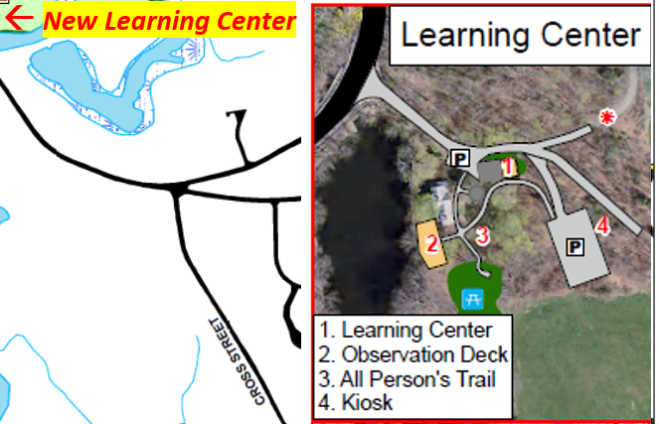

**Terms & Conditions**

If approved, this request (permit), must be carried by the Responsible Party/Permittee and may be revoked if the user(s) do not follow these conditions.

In case of emergency, please call:

Foxborough Police Department: 508-543-4343 and/or

Foxborough Fire Department: 508-543-1238

I (Permittee) hereby certify that I have read and understood the Foxborough Conservation Land Rules and Regulations (attached) and agree to abide by them. The Permittee shall indemnify and save harmless the Town of Foxborough and all of its officers, agents and employees for any suits, causes of action, claims, judgments or other liability, including without limitation reasonable counsel fees and expenses that may arise as a result of Permittee’s use of Town Conservation Land.

The Permittee may be required to provide to the Town of Foxborough, prior to the date of use of Town property, a certificate of insurance evidencing that the Permittee carries insurance with a licensed insurance company acceptable to the Town. Such insurance shall name the Town of Foxborough as an additional insured and shall not be cancelled or modified prior to the completion of use of Town property.

**I agree to the terms and conditions above.**

___________________________________________

Signature of Responsible Party/Permittee

**Foxborough Conservation Land Rules & Regulations - Lane**

Foxborough conservation land is managed by the Foxborough Conservation Commission (“Commission”) for passive or recreational activities, where appropriate, as well as to promote biodiversity. The Commission and the Conservation Agent (“Agent”) are tasked with maintaining, enhancing and/or conducting studies on conservation lands and are exempt from these Rules and Regulations.

1. **Hours / Trails**
2. Conservation landis open year-round from 1/2 hour before sunrise to 1/2 hour after sunset, unless authorized by the Commission or the Agent.
3. The cutting of trails and erection of signs is prohibited without the Commission’s written approval.
4. During “mud season” or for other environmental reasons, trails may be closed without prior notice; trail closure notifications will be posted on the Commission’s website.
5. **Property**
6. The dumping of yard waste and debris is prohibited.
7. Carry out what you carry in; littering and/or dumping of any materials are prohibited.
8. Possession of alcoholic beverages or glass containers is prohibited.
9. Metal detectors are not allowed; removal of artifacts is prohibited.
10. **Vehicles**
11. The operation of motor vehicles including, but not limited to, motorcycles, dirt bikes, ATVs, OHVs, and snow-mobiles is prohibited (see Foxborough Code, Part II, Ch. 256).
12. Vehicles should park in designated parking areas or, where unavailable, safely along public roads.
13. Parking after authorized hours is prohibited, unless permitted by the Commission or Agent.
14. **Animals**
15. Control of pets must conform to the Town’s animal control laws (Foxborough Code, Part II, Ch. 78).
16. The collection of wildlife is prohibited.
17. The introduction of any non-native wildlife is prohibited.
18. Target shooting and trapping are prohibited.
19. **Hunting** is not allowed on the Lane Homestead Property or the Neponset Reservoir.
20. **Plants**
21. The removal, cutting or damaging of trees, shrubs, plants, flowers and/or fungi is prohibited.
22. The collection of plants is prohibited.
23. The introduction of non-native plants is prohibited.
24. **Group Activities and Camping by Scouting Groups**

Group activities (ten or more people) are allowed on conservation land *only* after obtaining specific written permission from the Commission.

A completed *“Permit Request for Scouts to Camp at the Lane Conservation Area”* application must be submitted to the Commission *at least 21 days in advance* of any proposed group activity. Application forms are available online and at the Foxborough Town Hall. Applications must include (a) evidence that the Chief of Police has been notified of the proposed group activity, and (b) if a fee is to be charged for an event, proof of insurance liability coverage.

The following activities may be allowed with the Commission’s written permission:

1. Group activities such as scouting events, classes of instruction, picnics, weddings, outdoor dances, business lunch meetings and other similar events.
2. Recreational activities such as hiking, orienteering, skating, etc.
3. Camping by scouting groups.
4. Use of land for agriculture or forestry.
5. No open fires or cooking fires*,* without written approval of both the Commission *and* the Fire Department (see Lane Conservation Area Fire Pit Use Guidelines, next page).
6. Organized or commercial events which *charge fees* or raise or collect funds for any purpose, with proof of insurance liability coverage.

If a group activity has been approved, the Commission’s ***written permission*** (this form) ***must be carried by the person in charge of the event at all times*** during the event.

1. **Additional Important Information**
2. The Commission reserves the right to amend these regulations and to prohibit any inappropriate activities, not specifically listed above.
3. You are entering upon the land at your own risk. Neither the Town of Foxborough nor private landowners assume any liability for injuries to persons or damage to their property while on conservation land.
4. These regulations will be enforced by the Foxborough Police Department, the Conservation Commission, and/or the Conservation Agent (who is authorized to act on behalf of the Commission).
5. Copies of all current regulations are available online and at the Foxborough Town Hall.
6. If you have any questions or comments, please contact the Conservation Agent at the Town Hall. In the case of an emergency, please call the Foxborough Police at 911.
7. Please enjoy your visits to the conservation lands of Foxborough. These regulations have been published for your benefit, safety, and enjoyment of conservation lands.

***Thank You! It’s Your Land… ENJOY IT!***

**Lane Conservation Area**

**Fire Pit Use Guidelines**

1. Before beginning to use any fire pit at the Lane Property, you must first obtain:
2. Approval from the Conservation Commission (after completing this form), and
3. Permission from the Fire Department (508-543-1230).
4. Adult supervision is required at all times.
5. Never leave any fire unattended.
6. Please bring your own supply of *local* firewood (dry kindling may be collected from the woods for use).
7. At least five (5) gallons of water must is available at all times during fire pit use.
8. Bring a metal rake; soak and then spread out coals with your rake after the event to be sure that the fire is completely out.
9. Leave area free of trash and any debris.

Please Note:  
Use of any Lane Conservation Area Fire Pit (after Commission’s approval) is at your own risk; the Town of Foxborough shall bear no responsibility for any bodily injury or personal property damage that may result from fire pit use.